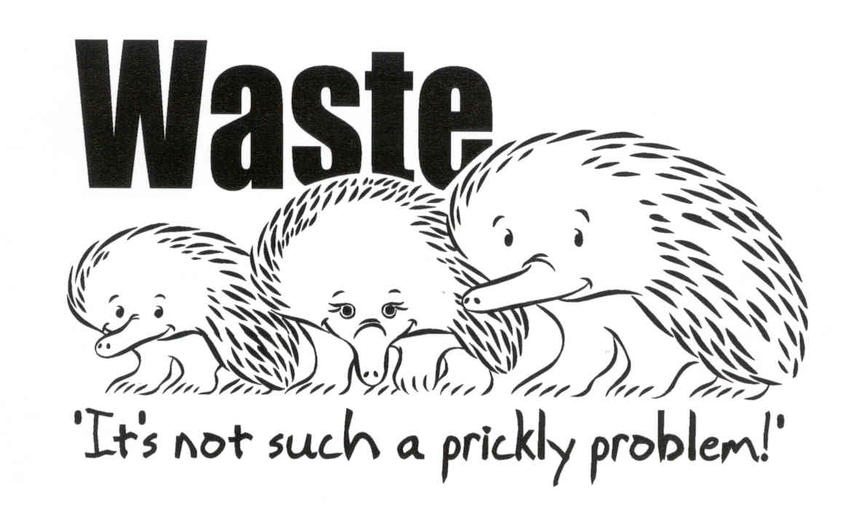
WASTE MANAGEMENT PLAN

To facilitate waste management and reduction, Council requires on-site sorting and storage of waste products pending re-use, recycling or collection.

The applicable sections of the following waste management plan must (at a minimum) be completed and submitted with applications which involve the demolition, design and construction, the use of a building and on-going management.

Larger developments should include the level of detail which reflects the scale of the development. The Resource NSW website contains a number of best practice publications that may be of assistance for more detailed waste management planning activities.

The information provided in the waste management plan will enable an assessment of how it is intended to re-use, recycle and dispose of waste. The information will be assessed against prescribed targets for the minimisation of waste disposal.

Outline of Proposal
Site Address:
Applicant’s name and address:
Phone: | Fax:
Buildings and other structures currently on the site:
Brief Description of Proposal:
The details provided on this form are the intentions for managing waste relating to this project
Signature of Applicant: | Date:

SECTION ONE – DEMOLITION STAGE

To be completed for applications involving demolition, excavation or residential subdivision (where involving 6 or more lots).

MATERIALS ON SITE | DESTINATION AND QUANTITY OF WASTE  REUSE AND RECYCLING DISPOSAL
TYPE OF  MATERIAL | ESTIMATED VOLUME (M³) *see A2.01 to help determine volume | ESTIMATED WEIGHT (kg)  *see A2.01 to help determine weight | ON-SITE  * see A1.02 for suggestions |  | OFF-SITE  * see A1.02 for suggestions  * see appendix A1.04 for outlets |  | * see A1.03 for transfer stations and landfills
 |  |  | Quantity (kg) | Use | Quantity (kg) | Probable destination | Quantity (kg) | Probable destination
Excavation
Material

Green
Waste

Bricks

Concrete

Tiles

(Section One – Demolition Stage – continued )

MATERIALS ON SITE | DESTINATION AND QUANTITY OF WASTE  REUSE AND RECYCLING DISPOSAL
TYPE OF  MATERIAL | ESTIMATED VOLUME (M³) *see A2.01 to help determine volume | ESTIMATED WEIGHT (kg) *see A2.01 to help determine weight | ON-SITE  * see A1.02 for suggestions |  | OFF-SITE  * see A1.02 for suggestions  * see A1.04 for outlets |  | * see A1.03 for transfer stations and landfills
 |  |  | Quantity (kg) | Use | Quantity (kg) | Probable destination | Quantity (kg) | Probable destination
Timber -
Please Specify

Plasterboard

Metals
Please Specify

Other –
Please Specify

TOTAL WASTE | __________________kg (100%) |  | ______________kg (_______%) |  | ______________kg (_______%) |  | ___________kg (_______%)

Does the combined re-use and recycling of waste materials meet Council’s target of 60% or greater (Yes/No) ______________.
If no, revisit the table to see where improvements may be achieved. If the target is still not possible, please state reasons why:

SECTION TWO – DESIGN STAGE

To be completed for all applications involving the design of buildings.

Choice of Building Materials

 | Building Materials | Reused or Recycled | Ecological Sustainability of Building Materials  (See A3.01)
Used |  | Used  () | Considered  ()
( )  ( )  ( )  ( )  ( )  ( )  ( )  ( )  ( )  ( ) | External Wall Type:  Brick  Timber/Weatherboard  Autoclaved Aerated Concrete  Concrete  Stone  Fibrous Cement  Hardiplank  Steel  Aluminium  Other (Specify)………………………. | ( )  ( )  ( )  ( )  ( )  ( )  ( )  ( )  ( )  ( ) | ( )  ( )  ( )  ( )  ( )  ( )  ( )  ( )  ( )  ( )
( )  ( )  ( ) | Frame:  Timber  Steel  Other (Specify)………………………. | ( )  ( )  ( ) | ( )  ( )  ( )
( )  ( )  ( )  ( )  ( )  ( )  ( )  ( ) | Internal Wall Type:  Brick  Timber  Autoclaved Aerated Concrete  Concrete  Stone  Plasterboard  Insulation (Specify)………………….  Other (Specify)………………………. | ( )  ( )  ( )  ( )  ( )  ( )  ( )  ( ) | ( )  ( )  ( )  ( )  ( )  ( )  ( )  ( )
( )  ( )  ( )  ( )  ( ) | Ground Floor Type:  Concrete Slab on Ground  Suspended Concrete Slab  Suspended Timber  Insulation (Specify)………………….  Other (Specify)…………………….… | ( )  ( )  ( )  ( )  ( ) | ( )  ( )  ( )  ( )  ( )
( )  ( )  ( )  ( )  ( )  ( ) | Floor Covering:  Tiles  Slate  Carpet  Timber  Vinyl  Other (Specify)…………………….… | ( )  ( )  ( )  ( )  ( )  ( ) | ( )  ( )  ( )  ( )  ( )  ( )
( )  ( )  ( )  ( )  ( )  ( )  ( )  ( ) | Roof Covering:  Concrete Roof Tiles  Terracotta Roof Tiles (Clay)  Slate  Metal deck  Aluminium  Fibreglass/Plastics  Insulation (Specify)………………….  Other (Specify)…………………….… | ( )  ( )  ( )  ( )  ( )  ( )  ( )  ( ) | ( )  ( )  ( )  ( )  ( )  ( )  ( )  ( )
( )  ( )  ( )  ( )  ( )  ( )  ( ) | Notable Site Works:  Asphalt Driveways/Paving  Concrete Driveways/Paving  Brick Fences/Walls  Timber Fences/Walls  Concrete Fences/Walls  Stone Fences/Walls  Other (Specify)…………………….… | ( )  ( )  ( )  ( )  ( )  ( )  ( ) | ( )  ( )  ( )  ( )  ( )  ( )  ( )
Note: Tick boxes to indicate what building material is used, whether it is reused or recycled and whether its ecological sustainability qualities have been considered.
(Section Two – Design Stage - continued)

Building Design

Design Techniques | Used
The appropriate location of waste management facilities | ( )
Design energy efficient housing to minimise energy consumption and use of fossil fuels (see Energy Efficient Housing Policy) | ( )
Design to standard material sizes, use modular construction, prefabricated material and basic designs to reduce the need for off-cuts | ( )
Specify the use of second hand, recycled or resource efficient building materials | ( )
“Design for deconstruction” techniques should be used so materials can be easily reused/recycled at the end of the life span of the building | ( )
Retrofit and repair existing buildings | ( )
Design to minimise excavation | ( )
Re-use off-cuts in building design | ( )
Design and specify for the smallest possible satisfactory solution | ( )
Retain a copy of the building plans and specifications with the building to aid maintenance and resource recovery at the end of a buildings lifespan | ( )
Landscape design incorporates an area for composting | ( )
Other (Specify)…………………………………………………… | ( )
Note: Tick boxes where design techniques have been or will be utilised to minimise waste.

SECTION THREE – CONSTRUCTION STAGE

To be completed for all applications involving construction of buildings.

MATERIALS ON SITE | DESTINATION AND QUANTITY OF WASTE  REUSE AND RECYCLING DISPOSAL
EXPECTED  WASTE  MATERIALS | ESTIMATED VOLUME (M³) *see A4.01 to help determine volume | ESTIMATED WEIGHT (kg) *see A4.01 to help determine weight | ON-SITE  * see A1.02 for suggestions |  | OFF-SITE  * see A1.02 for suggestions  * see A1.04 for outlets |  | * see A1.03 for transfer stations and landfills
 |  |  | Quantity (kg) | Use | Quantity (kg) | Probable destination | Quantity (kg) | Probable destination
Excavation
Material

Green
Waste

Bricks

Concrete

Tiles

(Section Three – Construction Stage – continued)

MATERIALS ON SITE | DESTINATION AND QUANTITY OF WASTE  REUSE AND RECYCLING DISPOSAL
EXPECTED  WASTE  MATERIALS | ESTIMATED VOLUME (M³) *see A4.01 to help determine volume | ESTIMATED WEIGHT (kg) *see A4.01 to help determine weight | ON-SITE  * see A1.02 for suggestions |  | OFF-SITE  * see A1.02 for suggestions  * see A1.04 for outlets |  | * see A1.03 for transfer station and landfills
 |  |  | Quantity (kg) | Use | Quantity (kg) | Probable destination | Quantity (kg) | Probable destination
Timber -
Please Specify

Plasterboard

Metals –
Please Specify

Other –
Please Specify

TOTAL WASTE | ________________kg (100%) |  | ______________kg (_______%) |  | _______________kg (_______%) |  | ___________kg (_______%)

Does the combined re-use and recycling waste meet Council’s target of 60% or greater (Yes/No) ______________.
If no, revisit the table to see where improvements may be achieved. If the target is still not possible, please state reasons why:

SECTION FOUR – USE AND ON-GOING MANAGEMENT

To be completed for all applications involving the construction of residential accommodation and commercial and industrial developments or for the change of use of same.

Describe how you intend to ensure on-going management of waste on-site. Issues which may require to be addressed include maintenance, signage and responsibilities.

ISSUE |  | PROPOSED ARRANGEMENTS

Size and Location
 | Use of premises.
 | Number of dwellings/units.
 | Estimated garbage generation (See A6.01).
 | Estimated recycling generation (See A6.01).
 | Number of and capacity of waste storage bins and volume handling and reduction equipment to be used for managing garbage.
 | Number of and capacity of waste storage bins and volume handling and reduction equipment to be used for managing recyclables.
 | Number of and capacity of waste storage bins and volume handling and reduction equipment to be used for managing garden organics (if applicable).
 | Area/s allocated for waste storage and recycling area and volume handling and reduction equipment (highlight on plan drawings).

On-site Access
 | Describe arrangements for on-site access by residents to waste facilities (highlight on plan drawings)
 | Describe arrangements for on-site access by collection contractors to waste facilities (highlight on plan drawings)
Design and Construction
 | Describe the fire safety features and protection equipment provided.
 | Describe how noise associated with residents using the bins, collection contractors emptying the bins and waste falling through and out of the bottom of a garbage chute has been minimised.
 | Describe any features for preventing ingress of vermin into waste storage areas.
 | Describe measures taken to ensure waste storage areas are aesthetically consistent with the rest of the development.
 | Describe the light source and method of ventilation within waste storage areas.
 | Describe facilities for washing bins, waste storage areas and garbage chute systems.
 | Describe the features incorporated in the design of the volume handling and reduction equipment to ensure its safe and efficient operation.
On-going Waste Management
 | Identify the time frame that it will take to introduce an environmental management system (i.e. waste minimisation and management strategy).
 | Describe arrangements for the cleaning and maintenance of waste storage areas and volume handling and reduction equipment.
 | Describe arrangements for ensuring appropriate signage and ensuring residents/tenants are aware of how to use the waste management system correctly.
 | Identify each stage of waste transfer between residents’/tenants’ units and loading into the collection vehicle. Who is responsible for each transfer?
 | Describe arrangements for the disposal of hazardous waste (if applicable)(See A6.02).

