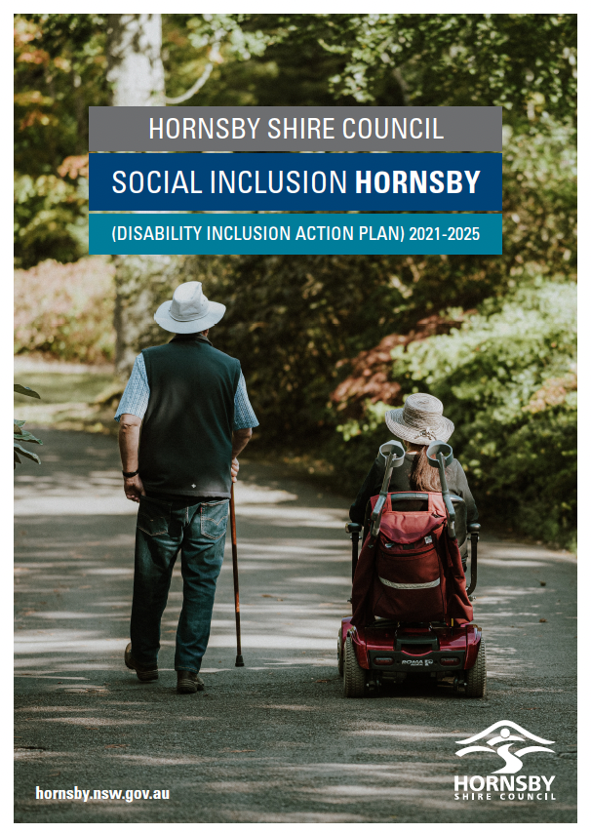
Contents
1. Acknowledgement 4
2. Connections to Country 5
3. Message from the Mayor 6
4. Introduction 7
4.1 What is disability? 7
4.2 Why is this important for Hornsby Shire? 7
4.3 Relevant policy and legislation 8
4.4 How will we support people with disability? 11
4.5 A note on language use 11
5. Disability in Australia 12
6. Community Profile 13
7. How we developed this plan 14
7.1 Reviewing our previous plan 14
7.2 What we have achieved 15
7.2.1 Focus Area 1: Developing positive community attitudes and behaviours 15
7.2.2 Focus Area 2: Creating liveable communities 15
7.2.3 Focus Area 3: Supporting access to meaningful employment 16
7.2.4 Focus Area 4: Improving access to mainstream services through better systems and processes 16
7.3 What we still need to do 17
7.3.1 Focus Area 1: Developing positive community attitudes and behaviours 17
7.3.2 Focus Area 2: Creating liveable communities 17
7.3.3 Focus Area 3: Supporting access to meaningful employment 17
7.3.4 Focus Area 4: Improving access to mainstream services through better systems and processes 18
7.4 Asking the community 19
7.4.1 What did we find out? 20
8. Our Social Inclusion Actions for 2021 - 2025 23
8.1 Focus Area 1: Developing positive community attitudes and behaviours 23
8.2 Focus Area 2: Creating liveable communities 23
8.3 Focus Area 3: Supporting access to meaningful employment 24
8.4 Focus Area 4: Improving access to services through better systems and processes 24
8.5 Detailed actions 25
9. How we will deliver the plan 34
10. How we will fund the plan 35
11. How we will consult with you 36
12. How we will measure success 37
13. Need Help? 38

Acknowledgement
We acknowledge the Traditional Custodians of this land, the Darug and GuriNgai peoples, and pay respect to their Ancestors and Elders past and present and to their Heritage. We acknowledge and uphold their intrinsic connections and continuing relationships to Country.
We would also like to express our appreciation and thanks to everyone who contributed to the development of this Social Inclusion Hornsby (Disability Inclusion Action Plan) 2021-2025.

Connections to Country
The area now known as Hornsby Shire is unique in its placement within the landscape with natural features differing from those that surround and beyond.
The meandering ridge lines extending from the south, north-west and north-east, meet here at Hornsby and expose its importance within the cultural landscape as a junction for these once heavily occupied travel routes. An extremely important resource for all Mobs traversing across Country for business, ceremony or family obligations and responsibilities.
From the ocean shores of Brooklyn, abundant in edible sea life and favourably utilised for its tasty treasures, to the rainforest covered gullies with constant supplies of native edible vegetation, grazing marsupials and rock shelters contribute to the uniqueness of this region.
The Darug and GuriNgai Peoples have protected and respected this area since time began. Sacred sites were etched into the sandstone by our Creator Ancestors about cultural knowledge, lore and law of Country, community, astronomy and weather patterns, to name only a few. These are scattered strategically throughout this landscape and are still utilised today for ceremonies, celebrations and Family gatherings and to pass cultural knowledge onto the next generations.
For the Darug and GuriNgai Peoples, this region is still alive and thriving from a cultural perspective. Despite the ever-growing demands for development and community infrastructures, the Hornsby Shire has lush and vibrant bushland areas, fresh and saltwater estuaries and breath-taking visual aspects across Country allowing us the ability to continue cultural practices, share cultural beliefs and expand on our relationship and connection with our Country.
The Darug and GuriNgai Peoples will continue to care for and respect Country. We invite and encourage you to expand on your own connection to this unique and amazingly beautiful Country. In the early morning hours when the sun is rising and you breathe in the fresh, clean air of a new day, pay homage to Mother Earth and the Aboriginal Mobs that have protected, respected, utilised and honoured these lands for its lifetime, always being mindful of never depleting resources or damaging natural features created by Mother Earth and our Creator Ancestors.
Tracey Howie, local bloodline descendant

Message FROM THE MAYOR
The implementation of the Social Inclusion Hornsby (Disability Inclusion Action Plan) 2021-2025 is a key initiative central to Hornsby Shire Council's Delivery Program and Operational Plan for the next twelve months and for years into the future.
A primary goal of Council is to ensure that Hornsby Shire is a resilient and welcoming community whose members care for and look after each other by connecting and participating in community life while enhancing social diversity and resilience.
The implementation of Social Inclusion Hornsby will promote social equity within the community, specifically by enhancing disability and diversity access and inclusion.
Nobody should ever feel excluded from the community in which they live nor feel they have been denied their right to pursue happiness and fulfillment.
Indeed, the community itself is better for taking active steps to ensure all our citizens not only feel included but are actively empowered to fully participate in society.
As this Plan demonstrates, when we take actions to include people it not only benefits them, it also benefits the broader community socially, culturally and economically by ensuring that everyone may pursue the opportunities life presents and thrive as fully-participating members of our community.
I congratulate all those who contributed to the development of this excellent Social Inclusion Hornsby (Disability Inclusion Action Plan) and look forward to Council implementing its many commendable objectives and goals.

Philip Ruddock AO
Mayor

Introduction
Everyone has the right to be a part of their community, and to be able to pursue their goals in life. Our community is better when we work to include all people. When we include people it not only benefits them, but we know it also benefits everyone socially and economically by providing opportunities to connect and to do business. This in turn allows us to lead richer and happier lives.
That’s why we want to make sure that people with disability, their families and support workers are included in Hornsby Shire and that our community is more accessible. This plan is your guide to how we are going to work with the community to make it more accessible, and how that will benefit all of us.

What is disability?
Defining disability can be tricky as disability presents in many ways and can mean different things to different people. We use the definition of disability from the NSW Disability Inclusion Act 2014, which states that disability:

“in relation to a person, includes a long-term physical, psychiatric, intellectual or sensory impairment that, in interaction with various barriers, may hinder the person’s full and effective participation in the community on an equal basis with others.”
The need to support inclusion is recognised at many levels of legislation and policy in Australia.
In 2014, the NSW Government passed a law that said that all local councils must have a Disability Inclusion Action Plan. The law is called the Disability Inclusion Act 2014. Under the law, councils must review their Disability Inclusion Action Plans every four years.

Why is this important for Hornsby Shire?
As a Council, we have a responsibility to look for, and where we can, remove the barriers that stop people from being involved in our community. The need to support inclusion is recognised at many levels of legislation and policy in Australia.
Council’s Disability Inclusion Action Plan for 2021-2025, known as Social Inclusion Hornsby, also forms part of a range of policies and plans that Hornsby Shire Council has in place to deliver its activities and engage with the community, including our Community Strategic Plan, Community Engagement Plan, and annual operational plans. The relationship of this plan to our other plans and reporting is shown in the figure on the following page. What is important is that Council commits to ongoing engagement with the community, monitoring of our progress, and reporting to the public.

Relevant policy and legislation
The need to support inclusion is recognised at many levels of legislation and policy in Australia.
In 2014, the NSW Government passed a law that said that all local councils must have a Disability Inclusion Action Plan. The law is called the Disability Inclusion Act 2014. Under the law, councils must review their Disability Inclusion Action Plans every four years.
The National Disability Insurance Scheme (NDIS) has also led to significant changes to supports for people with disability. The NDIS provides support to people aged under 65 years who have a permanent disability that significantly affects their ability to take part in everyday activities, as well as to people with disability who would benefit from early intervention. Participants receive individualised funding to access reasonable and necessary supports to meet their goals.
The Information, Linkages and Capacity Building component of the NDIS provides information and supports to people with disability, their families and carers, and supports mainstream and community services to be more inclusive. But the NDIS does not replace the obligation on mainstream and community services to be inclusive.
To create Social Inclusion Hornsby, we referred to a range of local, state, national and international policies, strategies and research. These included:
Council Strategies
- Community Strategic Plan 2018 – 2028
- Long Term Financial Plan 2018 – 2028
- Active Living Hornsby
- Equal Employment Opportunities Management Plan
- Pedestrian Access and Mobility Plan
- Integrated Land Use and Transport Strategy
- Community and Cultural Facilities Strategic Plan
- Community Engagement Plan
- Delivery Program
- Operational Plan
External Strategies and Laws
- UN Convention on the Rights of People with Disabilities (2006)
- Disability Discrimination Act (1992)
- Anti-Discrimination Act (NSW) (1977)
- Disability Inclusion Act (2014)
- Carers (Recognition) Act (2010)
- NSW Disability Inclusion Action Plan 2020-2025
- NSW Carers Charter
- Disability (Access to Premises - Buildings) Standards (2010)
- AS1428 - Australian Standards for Access and Mobility
- Ageing Well in NSW: Seniors Strategy 2021–2031
- Dementia Australia: Dementia friendly communities toolkit for local government

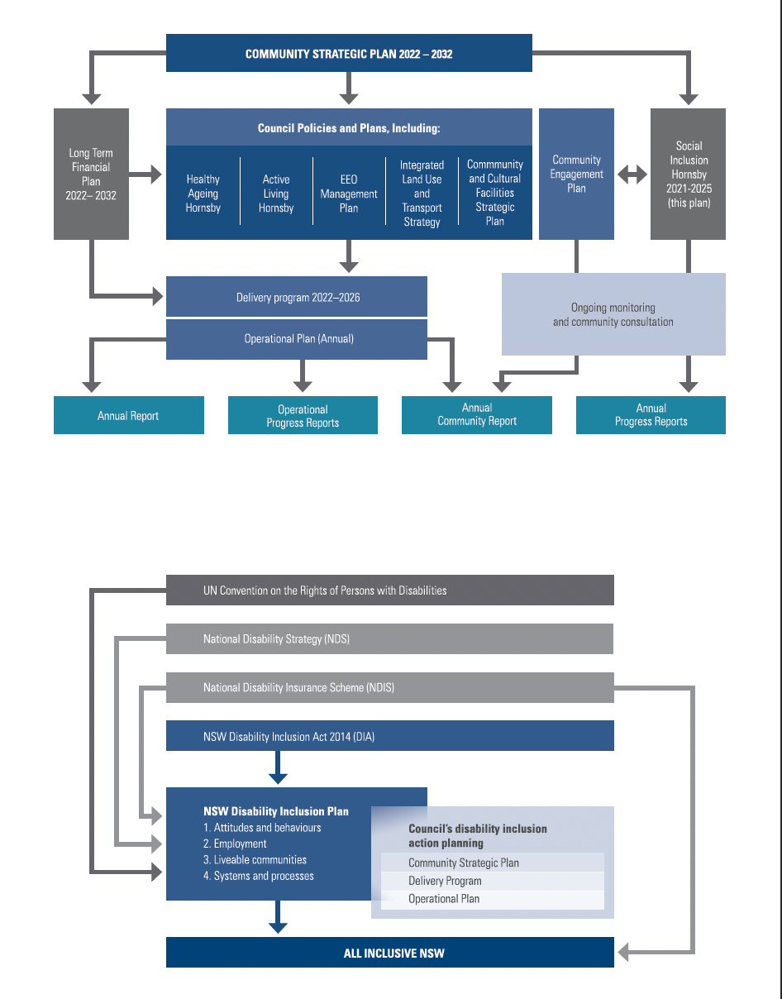

How will we support people with disability?
We are committed to making our community more accessible and inclusive of people with disability.
We will do this by:
- promoting positive attitudes and behaviours toward people with disability
- making improvements to ensure our community is easier to live in and to get around
- helping to facilitate access to volunteering and work opportunities for people with disability
- making sure the information we provide is easy to understand and our services are accessible and inclusive.
In the following pages, you will find out more about disability in our community, and how we are going to make Hornsby Shire more accessible and inclusive over the next four years.

A note on language use
For this document we have chosen to use person-first language (e.g. “person with disability”), consistent with the recommendations of the People with Disability Australia (PWDA) Language Guide of August 2021 and the Australian Government Style Manual. We do this to recognise the individual, and the wide variety of conditions and situations that can give rise to impairment.
However, we recognise that some people prefer to use identity-first language to describe themselves (e.g. “disabled person”). While this document uses person-first language, we are guided by the disability community when delivering activities. We ensure that when working with individuals, we use the language that they prefer to identify with, so that their preferences are respected.

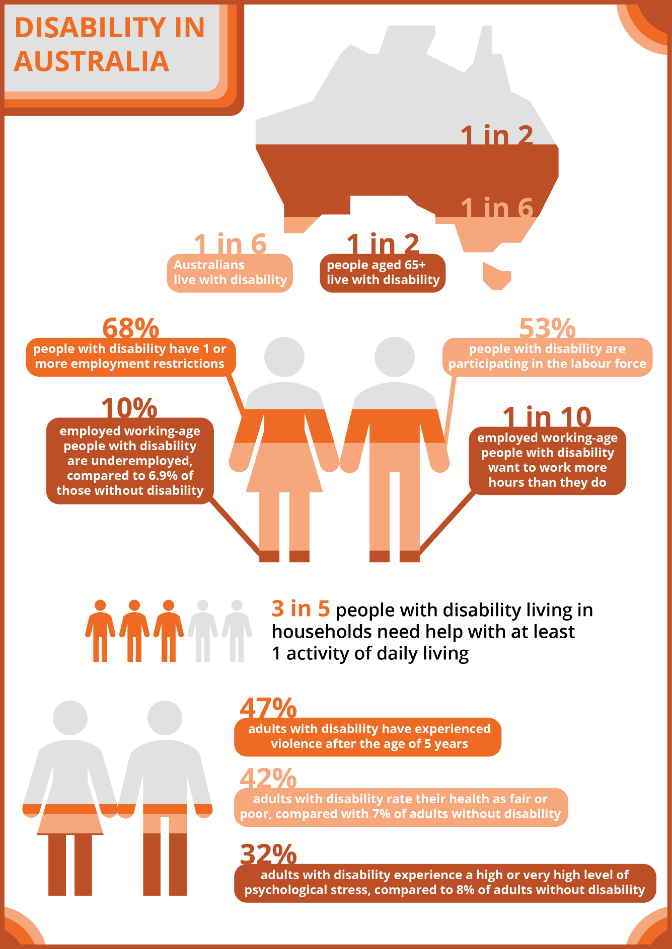
Disability in Australia

‘PWDA Language Guide: A guide to language about disability’, People with Disability Australia (2021)

Community Profile
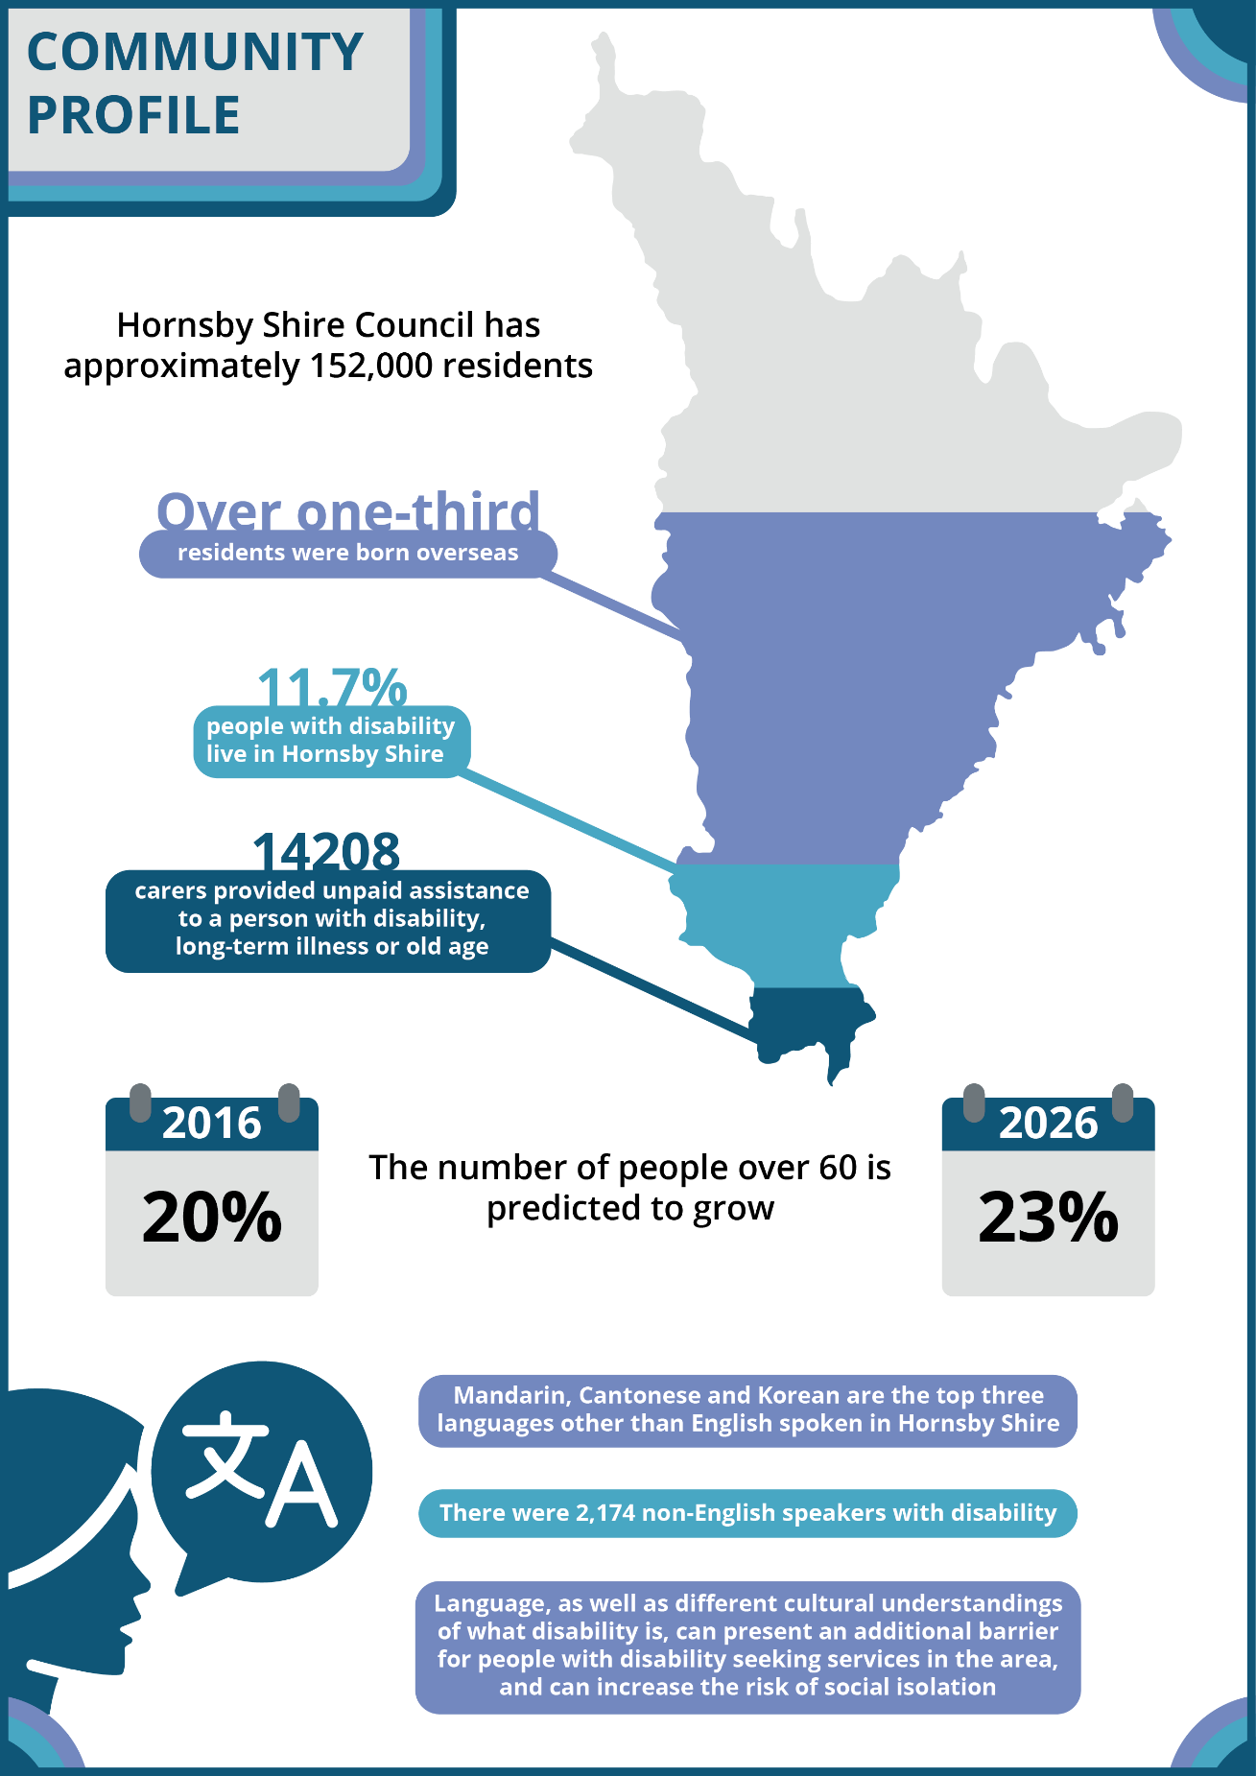
‘PWDA Language Guide: A guide to language about disability’, People with Disability Australia (2021)

How we developed this plan

Reviewing our previous plan
We reviewed our last Disability Inclusion Action Plan to find out what achievements had been made and what things we still need to do.

Of the 50 actions in our previous plan, 18 were not started and 3 were not completed. Many of these were affected by the COVID-19 pandemic, and so could not be started.

What we have achieved

Focus Area 1: Developing positive community attitudes and behaviours
Positive achievements:
- We celebrated International Day of Disabilities with an inclusive art exhibition in partnership with local service Studio Artes that supports people with disabilities.
- We delivered mandatory Equal Employment Opportunity online learning for all Council staff.
- We held information presentations for Culturally and Linguistically Diverse (CALD) community groups regarding Council’s service, programs and projects.
- All pages on Council websites now have the National Relay Service information in the footer.
- Council promoted the Studio Artes” Ride a Day in my Wheels” event and the “Share our space” initiative.
- The Communications and Engagement Team continues to seek opportunities to increase Council’s photo stock library to reflect disability and diversity.

Focus Area 2: Creating liveable communities
Positive achievements:
- In our community venues, we installed information display icons outlining the presence of amenities.
- Library staff delivered over 6,819 books and other resources to people in their homes during COVID-19 lockdowns.
- New online events and Storytime have been made available to the community via social media, including the use of captions to assist people who have difficulties with audio.
- Our inclusive play space at Waitara Park won the Play space award for projects over $0.5M in the 2020 regional NSW/ACT Parks & Leisure Australia Awards of Excellence. It is a safe and accessible park providing fun play experiences for children of all ages and abilities – bringing the community together.

Focus Area 3: Supporting access to meaningful employment
Positive achievements:
- We have provided casual employment for people with disabilities through arrangements with Disability Employment Program Provider, Nova Employment.

Focus Area 4: Improving access to mainstream services through better systems and processes
Positive achievements:
- We continue to provide accessible information during COVID-19 through information webinars, which included online Storytime, information for seniors and the CALD community, and learn to drive programs.
- We regularly review Council sites (twelve monthly or sooner if required) to ensure their compliance with the tenets of Australian Standard AS3745-2010 – Planning for Emergency In Facilities.

What we still need to do

Focus Area 1: Developing positive community attitudes and behaviours
Remaining actions:
- Develop an inclusive Communications Strategy.

Focus Area 2: Creating liveable communities
Remaining actions:
- Incorporate the location of specific information about footpaths, kerb ramps, and crossings, provided by DIAP respondents, into the proposed Pedestrian Access and Mobility Plan (PAMP).
- Update the Public Domain Guidelines to incorporate feedback from people with disability on improving accessibility and connections to centres, transport and open spaces.
- Increase the availability of mobility parking (complying with AS 2890) across the Shire.

Focus Area 3: Supporting access to meaningful employment
Remaining actions:
- Incorporate inclusion awareness (in relation to people with disability including hidden disability) into the staff induction program.
- Include skills for awareness of disability inclusion in current training needs analysis processes and in appropriate training programs.
- Continue to ensure job task analyses/position descriptions carefully describe the inherent requirements of the position.
- Implement the free resources from the Australian Network on Disability: Sharing and monitoring disability information in the workplace; Employers' Guide to Partnering with Disability Employment Services; and Manager's Guide: Disability in the Workplace.

Focus Area 4: Improving access to mainstream services through better systems and processes
Remaining actions:
- Provide guidelines and templates to enable staff to make all communications easy to read, accessible and inclusive (including to enable web accessibility).
- Develop a policy and procedure(s) for responding to requests for information in alternative formats.
- Ensure any committee or reference group to the traffic and/or safety committees include representation by people with disability.
- Review the procedures for handling complaints with Council to ensure better access for people with disability.
- Identify any access and inclusion related trends in data from feedback and complaint processes, and ensure issues are addressed in quality improvement cycle.
- Conduct more targeted strategy reviews of the proposed PAMP with the involvement of focus group(s) that include representatives with mobility, sensory and/or other disabilities.
- Training in website accessibility (including accessible PDFs) is to be resumed.

Asking the community
To update our previous Disability Inclusion Action Plan, we asked the community about the barriers that people with disability face in Hornsby Shire and their ideas for improvement. In late 2021, we consulted with:
- people with disability
- their families
- service providers
- other community members
- our External Advisory Group.

We worked with them to find out what key actions we can take to improve accessibility and inclusion of people with disability in Hornsby Shire.
We promoted our consultations through Council’s website, social media, Council facilities, the local papers, and emails, letters and phone calls to relevant stakeholders through Council’s contact lists and networks.
We held six consultation forums in November and December 2021, open to people with disability, older people, community organisations, and interested members of the community. The consultations were held face-to-face (in Berowra, Hornsby, Galston, Thornleigh and Cherrybrook) and online, and catered to all accessibility requirements.
People who could not attend the forums could tell us what they thought through an online survey, by completing a paper survey available through Council facilities and delivered to aged care homes, or by contacting Council directly via phone or email. In total, 1,215 members of the public completed the survey, including:
- 144 people with disability
- 148 family members and support workers
- 33 representatives from disability service organisations.
As well as the public survey, 224 Council staff responded to a survey on their understanding of disability and what they saw as priorities for a new plan.
We collated and analysed the feedback and presented this to Council staff.

What did we find out?
Our consultations provided the following valuable insights:
- Libraries, the Thornleigh Community Recycling Centre, and Aquatic and Leisure Centres are seen as very accessible spaces by people with disability, but more needs to be done to make footpaths, public toilets, council parking, drop-off and pick-up areas and bus shelters more accessible.
- We are seen as being good at providing information, but we can do better in consulting regularly with the community, and in providing information to people who can’t or don’t want to use computers.

We also found out the top six areas that Council needs to work on making more accessible for people with disability:
- public toilets
- footpaths
- information about Council facilities and services
- drop off and pick up areas
- natural areas
- Council car parking.

Key themes
Below is a high-level summary of the themes that emerged from consultation with the local community, service providers and staff on what we can do to improve access and inclusion in Hornsby Shire.
Focus Area: | Priorities for Improvement:
Community Attitudes and Behaviours | - Ensuring public events are accessible, welcoming and inclusive  - Greater training for businesses in interacting with people with disability  - Training Council staff on access and inclusion for people with disability  - Sharing public messages about inclusion for people with disability.
Creative Liveable Communities | - Maintaining safe footpaths linking shops, parks, homes and transport  - Advocating for the needs of people with disability with State and Federal Government  - Encouraging accessible-for-all design (universal design) in new housing  - More accessible toilets at community venues and parks  - More disability parking that is accessible, safe and in close proximity to venues.
Access to Meaningful Employment | - Working with people with disability to identify suitable tasks and training opportunities  - Providing both volunteering and paid employment opportunities for people with disability to build their skills  - Ensuring workplaces are accessible  - Educating staff about the rights, capabilities and merits of people with disability as employees and volunteers.

Focus Area: | Priorities for Improvement:
Improving Access to Services | - Making sure people can contact Council without needing a computer  - Utilising face-to-face and paper-based methods to distribute information to the community  - Continuous training for staff at Council’s customer service centre  - Consulting regularly with people with disability and their carers and families in how to improve services  - Making feedback and complaint options easy to find and accessible  - Disseminate information in different languages  - Central contact point for people with disability, and single point for people to report accessibility issues  - Website navigation improvements.

Our Social Inclusion Actions for 2021 - 2025

Focus Area 1: Developing positive community attitudes and behaviours
- Contribute to developing an inclusive community by promoting inclusion awareness and inclusive activities across Hornsby Shire.
  - Ensure inclusive communications are accessible
  - Deliver community education on appropriate language and respectful behaviours towards people with disability
- Create a workplace culture in Hornsby Shire Council that is aware of inclusion and has the skills to implement the improvements to inclusion suggested by people with disability.
  - Monitor and update Social Inclusion Hornsby every 12 months
  - Increase staff training and awareness of disability

Focus Area 2: Creating liveable communities
- Provide and maintain accessible paths, kerb ramps, crossings and toilets to support independent travel across Hornsby Shire
  - Review and maintain footpaths so they are accessible and safe for all people
  - Increase and improve accessible parking spots, ensuring they are suitable and located close to venues
  - Work with transport organisations and state government to make transport infrastructure more accessible
  - Ensure all toilets due for refurbishment meet existing disability building codes
- Improve the accessibility of buildings and public spaces across Hornsby Shire
  - Complete audits and upgrades so buildings and public spaces are accessible and safe for people with disability
  - Ensure parks and playgrounds are inclusive of people with disability
  - Develop standards and guidelines to maintain safe pathways and buildings that reflect universal design
- Increase the number of accessible and inclusive workshops, programs and events available in Hornsby Shire.
  - Encourage people with disability to attend Council events, by ensuring they are accessible
  - Provide programs and activities that are inclusive of CALD communities

Focus Area 3: Supporting access to meaningful employment
- Provide greater access for people with disability to employment opportunities with Council
  - Review Council recruitment processes to ensure they are accessible
  - Promote work experience, traineeships, volunteering and paid employment opportunities
  - Bring together Non-Government Organisations (NGOs), disability service providers, schools, local businesses and people with disability
  - Educate employers around employing people with disability

Focus Area 4: Improving access to services through better systems and processes
- Provide Council information in an easy-to-understand style, available in accessible formats, using a variety of media.
- Provide Council information in different formats and languages
- Update guidelines and templates so communications are easy to read
- Increase opportunities for people with disability to be involved in the design and/or implementation of built environments, Council systems, processes and/or services
- Engage in ongoing consultation with people with disability in ways that are accessible and inclusive and encourage their participation
- Improve the accessibility of Council processes and use feedback and complaints data to continually enhance access and inclusion.
  - Provide more training for our staff in assisting people with disability to meet their needs
  - Create a central contact point for people with disability around issues and questions relating to accessibility
- Continue to advocate for the local community by informing other agencies and levels of government about local access and inclusion needs.
  - Work with other levels of government and organisations to improve services for people with disability

Detailed actions
FOCUS AREA 1: DEVELOPING POSITIVE COMMUNITY ATTITUDES AND BEHAVIOURS
ID | ACTIONS | RESPONSIBILITY | TIMEFRAME | INDICATORS
Outcome 1: People with disability experience positive, inclusive attitudes and behaviours from Council staff and they agree that Council promotes inclusive attitudes in the broader community
Strategy 1.1: Contribute to developing an inclusive community by promoting inclusion awareness and inclusive activities across Hornsby Shire
1.1.1 | Ensure inclusive communications when planning public consultations on new strategies and plans | Communications and Engagement (lead)  Community and Cultural Development (support) | Ongoing | - Annual report on inclusion awareness raising strategies Council has contributed to
1.1.2 | Increase Council's photo stock library to reflect community disability diversity | Corporate Support Division (lead)  Communications and Engagement (support) | Ongoing | - Appropriate images used relevant to the communication and marketing material being prepared
1.1.3 | Provide positive updates of successful implementation of DIAP actions (as well as other examples of positive inclusion) on Council’s public communication channels (including both Council and community achievements) | Community and Cultural Development (lead)  Communications and Engagement (support) | Ongoing | - Post examples and update every quarter
1.1.4 | Deliver a targeted community education campaign on appropriate language and respectful behaviours towards people with disability, including invisible disability (i.e. mental health, neurodivergent conditions, intellectual disability) for schools, businesses, and community | Community and Cultural Development | December 2023 | - Campaign established and delivered
1.1.5 | Create a workplace culture in Hornsby Shire Council that is aware of the inclusion needs of people of all ages with disability and has the skills to implement the improvements to inclusion suggested by people with disability | All Departments | Ongoing | - Workplace culture aware of inclusion needs of people with disability and skills to implement the improvements suggested by people with disability
Strategy 1.2: Create a workplace culture in Hornsby Shire Council that is aware of the inclusion needs of people of all ages with disability and has the skills to implement the improvements to inclusion suggested by people with disability.
1.2.1 | Incorporate inclusion awareness (in relation to people with disability including hidden disability' into the staff induction program | People and Culture | July 2023 | - Inclusion of people with disability is incorporated in current Induction Program  - Incorporate inclusion of people with disability into any future onboarding program, including survey of new staff
1.2.2 | Include skills for awareness of disability inclusion in current training needs analysis processes and in appropriate training programs | People and Culture | December 2023 | - Review of current training needs analysis to include DIAP required skills, completed
1.2.3 | Provide a copy of Social Inclusion Hornsby to all Councillors | Strategy and Place | August 2022 | - Councillors informed of plan

FOCUS AREA 2: CREATING LIVEABLE COMMUNITIES
ID | ACTIONS |  | RESPONSIBILITY |  | TIMEFRAME |  | INDICATORS
Outcome 2: People with a disability have greater access to the built and natural environments of Hornsby Shire, and have opportunities to participate in a greater variety of accessible and inclusive events and activities
Strategy 2.1: Provide and maintain accessible paths, kerb ramps, crossings, and toilets to support independent travel across Hornsby Shire
2.1.1 | Investigate the location of specific information about footpaths, kerb ramps, and crossings, provided by DIAP respondents. |  | Asset Operations and Maintenance (lead)  Technology & Transformation (GIS) (support) |  | December 2024 |  | - Location specific information provided by DIAP respondents incorporated into the proposed Pedestrian Access Mobility Plan (PAMP) by December 2024
2.1.2 | Provide and maintain continuous accessible paths of travel across Hornsby Shire, in consultation with people with disability |  | Asset Operations and Maintenance |  | Ongoing |  | - Number of accessible paths of travel to key destinations added to the PAMP  - Number of accessible paths of travel completed
2.1.3 | Develop requirements around ensuring continued accessibility of footpath areas during construction work, particularly around footpath removal and wheeled access |  | Asset Operations and Maintenance |  | Ongoing |  | - Requirements are developed and promoted
2.1.4 | Include location specific access information on our website (toilets, kerb ramps, crossings) |  | Communications and Engagement |  | December 2023 |  | - Once information is provided (see 2.1.1) include in an appropriate location on Council’s website
2.1.5 | Accommodate accessibility needs as new public toilets are established or refurbished |  | Asset Operations and Maintenance (lead)  Parks, Trees and Recreation (support) |  | Ongoing |  | - Number of new or refurbished public toilets where accessibility needs are accommodated
2.1.6 | Investigate the availability of mobility parking (complying with Australian Standard 2890) across Hornsby Shire |  | Traffic Engineering and Road Safety |  | December 2024 |  | - Map of accessible parking across Hornsby Shire completed  - Report with recommendations on accessible parking provided as an addendum to the Parking Management Study in Hornsby Shire
2.1.7 | Advocate on behalf of Hornsby Shire residents with Transport NSW to make major transport infrastructure in Hornsby Shire more accessible and disability friendly including ramps, lifts, at bus interchanges and improved signage |  | Traffic Engineering and Road Safety |  | Ongoing |  | - Improvement program initiated  - Number of advocacy activities with Transport NSW and relevant ministers
Strategy 2.2: Improve the accessibility of buildings and public spaces across Hornsby Shire
2.2.1 | Complete accredited access audits of Council buildings and facilities whenever upgrades are planned, indicate risks to people with disabilities due to poor building access and ensure updated access information is included on Council’s website |  | Asset Operations and Maintenance |  | Ongoing |  | - Location specific information from the DIAP included in access audit  - Number of accredited access audits completed  - Number of complaints received, or incident reports related to poor building or facility access
2.2.2 | Ensure the Public Domain Guidelines incorporates feedback from people with disability on improving accessibility and connections to centres, transport, and open spaces |  | Infrastructure and Major Projects Division |  | Ongoing |  | - Number of amendments made to Public Domain Guidelines
2.2.3 | Ensure when park upgrades and renewals are undertaken, these accommodate accessibility needs (tracks, picnic facilities, etc.) |  | Parks, Trees and Recreation |  | Ongoing |  | - Rolling schedule or focus on reports
2.2.4 | Continue to implement accessible trails as part of Council's Track and Trail Masterplan |  | Natural Resources (support for inclusion on bush tracks) |  | Ongoing |  | - Reports on implementation of accessible trails in Track and Trail Masterplan
2.2.5 | As playgrounds are renewed, identify opportunities to incorporate inclusive and accessible play equipment |  | Parks, Trees and Recreation |  | Ongoing |  | - Number of renewed playgrounds upgraded to incorporate inclusive and accessible play equipment
2.2.6 | Continue to work with and encourage local businesses and venues to upgrade their premises to improve accessibility |  | Community and Cultural Development |  | Ongoing |  | - Number of businesses upgraded
2.2.7 | Council continues to work towards ensuring that all pontoons and access ramps under their management are safe and accessible to all boat users |  | Asset Operations and Maintenance |  | Ongoing |  | - Ramps under Council management are safe and accessible
Strategy 2.3: Increase the number of accessible and inclusive workshops, programs and events available in Hornsby Shire
2.3.1 |  | Consider Access and Inclusion Plans into all Council hosted programs, events and meetings |  | Community and Cultural Development (lead)  Other Council Branches providing events for the community (support) | Ongoing | - Number of major events and meetings hosted at inclusive venues
2.3.2 |  | In partnership with multicultural organisations, provide and promote inclusive activities and programs in Library, Waste Education, and Natural Resources workshops and programs |  | Community and Cultural Development (lead)  All Departments | Ongoing | - Number of workshops delivered in partnership (aged and/or disability)
2.3.3 |  | Promote events that are accessible and inclusive for people with disability, and provide information to the community on the specific measures in place that make these events accessible |  | Community and Cultural Development (lead)  Communications and Engagement (support) | Ongoing | - Number of accessible and inclusive events held

FOCUS AREA 3: SUPPORTING ACCESS TO MEANINGFUL EMPLOYMENT
ID | ACTIONS | RESPONSIBILITY | TIMEFRAME | INDICATORS
Outcome 3: People with disability have opportunities to gain employment with Council
Strategy 3.1: People with disability have greater access to employment opportunities with Council
3.1.1 | Continue to ensure job task analyses/position descriptions carefully describe the inherent requirements of the position | People and Culture | Ongoing | Job task analyses/position descriptions with inherent requirements described and available for all jobs
3.1.2 | Continue to work with disability employment agencies to provide work placement or workplace training opportunities in Council | People and Culture | Ongoing | Record of meetings or contacts with Disability Employment Services
3.1.3 | Host an employment forum with not-for-profit organisations, disability service providers, schools and local businesses to support transitioning people with disability into the workforce | Community and Cultural Development | December 2023 | Forum held/participation
3.1.4 | Work with employers on the opportunities and benefits in employing people with disability including through the provision of Social Enterprise training for local organisations and businesses | Community and Cultural Development | December 2023 | Social Enterprise training provided
3.1.5 | Implement the free resources from the Australian Network on Disability:  - Sharing and monitoring disability information in the workplace  - Employers' Guide to Partnering with Disability Employment Services  - Manager's Guide: Disability in the Workplace | People and Culture (lead)  Community and Cultural Development Services (support) | December 2023 | Information on sharing and monitoring disability information in the workplace included in policies and procedures  All managers are provided with Manager's Guide: Disability in the Workplace

FOCUS AREA 4: IMPROVING ACCESS TO SERVICES THROUGH BETTER SYSTEMS AND PROCESSES
ID | ACTIONS | RESPONSIBILITY | TIMEFRAME | INDICATORS
Outcome 4: People with disability agree that Council services are easier to access, and that they have greater opportunities to give their input to Council on a range of issues, to give feedback or to make complaints
Strategy 4.1: Provide Council information in an easy-to-understand style, available in accessible formats, using a variety of media
4.1.1 | Ensure guidelines and templates to enable staff to make all communications easy to read, accessible and inclusive (including to enable web accessibility) | Communications and Engagement (lead)  Technology and Transformation (support) | December 2023 | - Review brand guidelines, particularly fonts and backgrounds by December 2023
4.1.2 | Providing communications in multiple formats (online and paper), alternative media (video or voice), and in alternative languages for the CALD population | Communications and Engagement (lead) | Ongoing | - Council messages are delivered via various formats and in different languages or with translation services available
Strategy 4.2: Increase opportunities for people with disability to be involved in the design and/or implementation of built environments, Council systems, processes and/or services
4.2.2 | Investigate retaining the DIAP Advisory committee to meet minimum of twice a year or as necessary | Community and Cultural Development | December 2022 | - Inclusion Reference Group with Terms of Reference established
4.2.3 | Where possible, ensure any committee or reference group to the traffic and/or safety committees include representation by people with disability | Community and Cultural Development (lead)  Traffic Engineers and Road Safety (support) | Ongoing | - Terms of Reference for traffic / safety committees include need to have representation by people with disability
4.2.4 | Investigate the introduction of more targeted strategy reviews of the proposed Pedestrian Access and Mobility Plan (PAMP) with the involvement of focus groups that include representatives with mobility, sensory and/or other disabilities | Infrastructure and Major Projects | December 2024 | - Investigation completed
Strategy 4.3: Improve the accessibility of the Council processes, and use feedback and complaints data to continually enhance access and inclusion
4.3.1 | Review the procedures for handling complaints with Council to ensure better access for people with disability | All Departments with feedback / complaints procedures (lead)  Governance and Customer Service (support) | July 2023 | - Number of procedures for handling complaints with Council (including all libraries, galleries and pools) reviewed
4.3.2 | Review staff training for Council customer service officers on how to assist people with disability and to know where to access information on disability services | Learning and Development | July 2023 | - Training provided on information resources
4.3.3 | Create a central contact point for people with disability, support workers and families to contact Council around issues relating to accessibility | Community and Cultural Development | December 2022 | - Central contact point established
4.3.4 | Identify any access and inclusion related trends in data from feedback and complaint processes, and ensure issues are addressed in quality improvement cycle | All Departments with feedback / complaints procedures  Governance and Customer Service (support)  Community and Cultural Development (support) | Ongoing | - Data on feedback / complaints, with trends identified, relating to access and/or inclusion

Strategy 4.4: Continue to advocate for the local community by informing other agencies and levels of government about local access and inclusion needs
4.4.1 | Advocate for the needs of residents with disability to other levels of government, where needed | All Departments | Ongoing | - Number of representations made about access and inclusion of local people with disability to other levels of government and other agencies
4.4.2 | Advocate for the needs of residents with disability to external organisations | All Departments | Ongoing | - Representations made to emergency planning committee(s) about emergency planning for people with disability in Hornsby Shire

How we will deliver the plan
Everyone in Council has responsibilities for supporting access and inclusion. The actions that specific sections of Council are responsible for are noted in this plan.
Our Community and Cultural Development team will oversee Council’s ongoing implementation of this plan and will report to the Executive.

We will also:
- Review implementation every 12 months
- Seek ongoing feedback on progress from people with disability and other community members
- Seek ongoing feedback from our Social Inclusion Advisory Committee
- Seek ongoing feedback from Council staff
- Modify our strategies and actions according to review and feedback findings
- Present results of the review process to the Social Inclusion Advisory Committee
- Provide an annual report on our activities to the community and the Minister for Disability Services
- Conduct a full review after four years.

How we will fund the plan
Many of the actions in Social Inclusion Hornsby are things that we are doing already and will continue to do. These actions will also adapt to meet the changing needs of our community. These types of actions will not need more money and are already being funded by Hornsby Shire Council.

Some actions will need money to do, especially where we need to build things. Money for this will come from our budget process where possible. Sometimes, we may try and get money from other sources to help us deliver actions.

This will help us to deliver the actions in the plan responsibly and within our means.

How we will consult with you
We will seek feedback from people with disability and community members through:
- the surveys we use at events
- the ‘report an issue’ section on our website.
You can also contact Council's Community and Cultural Development team by emailing cdevelopment@hornsby.nsw.gov.au, or phoning (02) 9847 6996.
Consultants for Hornsby Shire Council’s Social Inclusion Hornsby:
Adorable Care | 1300 158 075
CASS | 9789 4587
Catholic Care | 9488 2520
Cubby House Childcare | 1300 553 583
Fusion | 9477 1111
Health (Hornsby Hospital) | 9477 9123
HK Children and Family Network | 9858 3029
HK Multicultural Network | 9988 4966
Just Better Care | 9934 9999
Multicultural Health NSW Communication Service NSW | 9932 9710
Northern Sydney Local Health District (Aboriginal Health Service) | 9477 9400
North Sydney Region Chinese Community Network | 9476 9715
Nova Employment | 1300 224 548
Mt Wilga Hospital | 9847 5000
Ryde Intercultural Network | 9858 3029
Studio Artes | 9482 5260
Uniting Australia | 1800 864 846

How we will measure success
We want to make sure that we are accountable for our actions. That is why every one of our actions has detail on what that action is meant to achieve, and how we will know if that has been achieved.

For some actions, that will mean checking whether we have done what we said we will do. For other actions, we will ask the community to tell us what they think, through conversations and surveys and feedback. We may also measure things like numbers of events or survey people on their attitudes over time.

We will measure our progress regularly and report every year on what has been done and what we still need to do as part of our annual report. We will also report to our External Advisory Group. This will make sure that we are doing what we said we would do, but also to make sure that our actions are still the right things to do for the community.

NEED HELP?
This document contains important information.

If you do not understand it, please call the Translating and Interpreting Service on 131 450. Ask them to phone 9847 6666 on your behalf to contact Hornsby Shire Council.

Council’s business hours are Monday to Friday, 8.30am – 5pm.

Contact Details
Hornsby Shire Council
ABN 20 706 996 972

Address Information
PO Box 37
Hornsby
NSW 1630
Phone: (02) 9847 6666
Fax: (02) 9847 6999
Email hsc@hornsby.nsw.gov.nsw.au
Web: hornsby.nsw.gov.au

Hornsby Shire Council Administration Centre
296 Peats Ferry Road
Hornsby
NSW 2077

For office hours, please check the website for the latest opening hours for the Customer Service Centre and Duty Officer – www.hornsby.nsw.gov.au

Disclaimer:
Every effort has been made to provide accurate and complete information. However, the authors assume no responsibility for any direct, indirect, incidental or consequential damage arising from the use of information in the document.

Copyright Notice
No part of this publication may be reproduced in any form, or stored in a database or retrieval system or transmitted or distributed in any form, by any means, electronic, mechanical photocopying, recording or otherwise, without written permission from Hornsby Shire Council.
All rights reserved.
Copyright © 2022, Hornsby Shire Council

People With Disability Australia (2021) ‘PWDA Language guide: A guide to language about disability’, People With Disability Australia

